Design Document

CMPT 450

Authors: Adrian Cate and Graham Cooper

Macewan University

Dr. Indratmo

March 15, 2019

**Purpose of the Application**

The purpose of the application is to design a visual idiom that allows users to:

* Explore the U.S. Dividend Champions
* Compare different sectors, industries, and companies
* Make informed decisions on potential investments

**Use Case scenarios**

Tom is completely new to the stock market and doesn’t know anything about the stock market, economics, finance, dividends, or business. Tom is interested in learning about where to invest his money and a dividend stock market information is a good place to learn about the performance of sectors, industries, and companies in the economy.

The user interface of the application has a zoomable tree-map on the left hand side that displays all the sectors, industries, and companies and on the right hand side in a scatter plot for user selected targets for comparison, but a bar chat would be used at the company level instead of a scatter plot. The user can zoom into the data and zoom out of the data with the zoomable tree-map. The user would be zooming into a specific sector then industry then a specific company within those zoom is where the users main decisions are made. Tom can select specific investment opportunities to compare against each other. Tom can also select specific statistics of his choice that he wants to compare that will show up in the chart on the right hand side.

Tom can select the ‘information’ sector to zoom into that sector and from there he can either compare other industries within the ‘information’ sector or zoom into an industry such as ‘Technology Hardware, Storage & Peripherals’. Tom again has the same choices again that he had at the sector level. Tom can compare other companies within this industry or zoom into a specific company. Tom has the option of selecting specific companies to compare by a drop down menu on the upper right had screen. He can also select specific stats that are in a drop down menu for the x-axis and y-axis on the char on the right hand side. After he has made his selections he can graph those and examine the data.

* The user can compare different: sectors, industries, and companies against each other.
* The user can select specific sectors, industries, and companies against each other to better understand the information.
* The user can zoom in and zoom out of the sectors, industries, and companies.
* The user can select specific statistics to compare.

**Low-fidelity prototype**

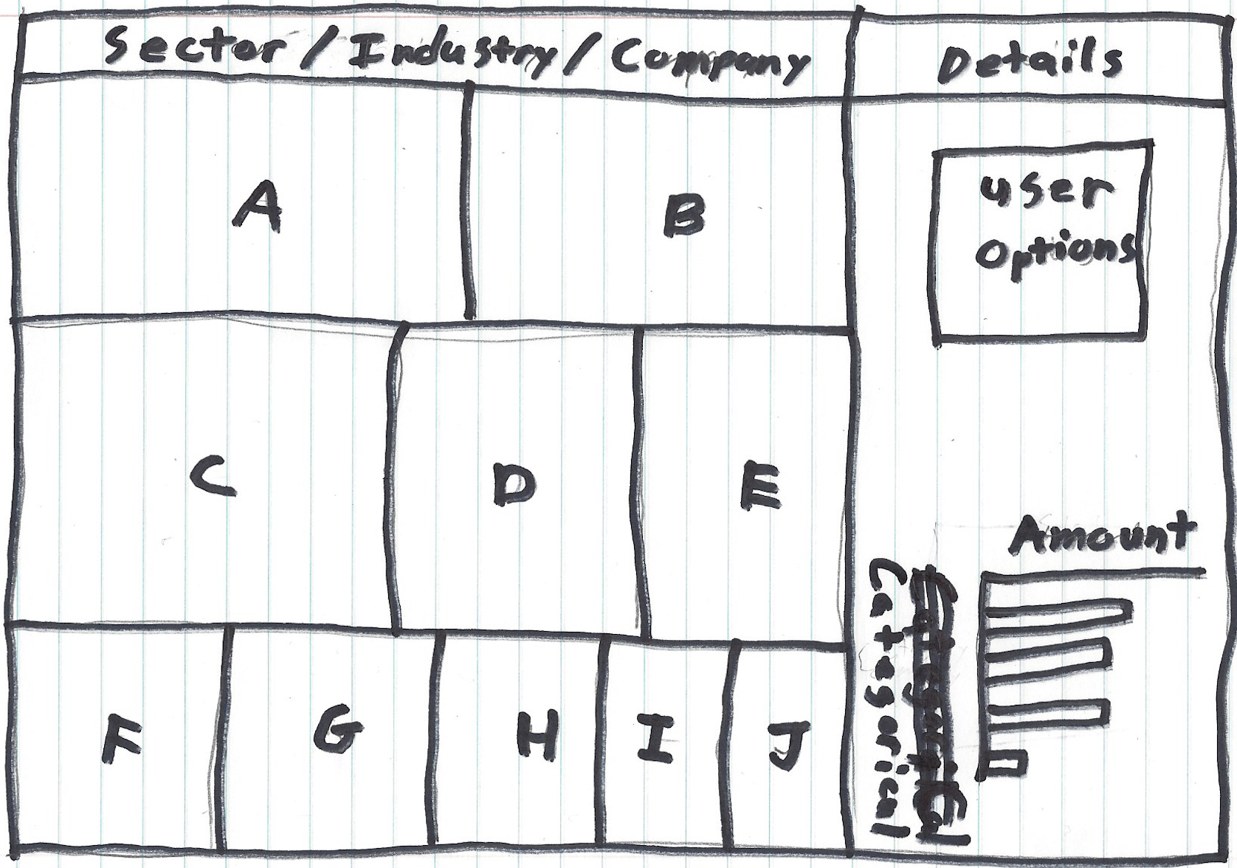

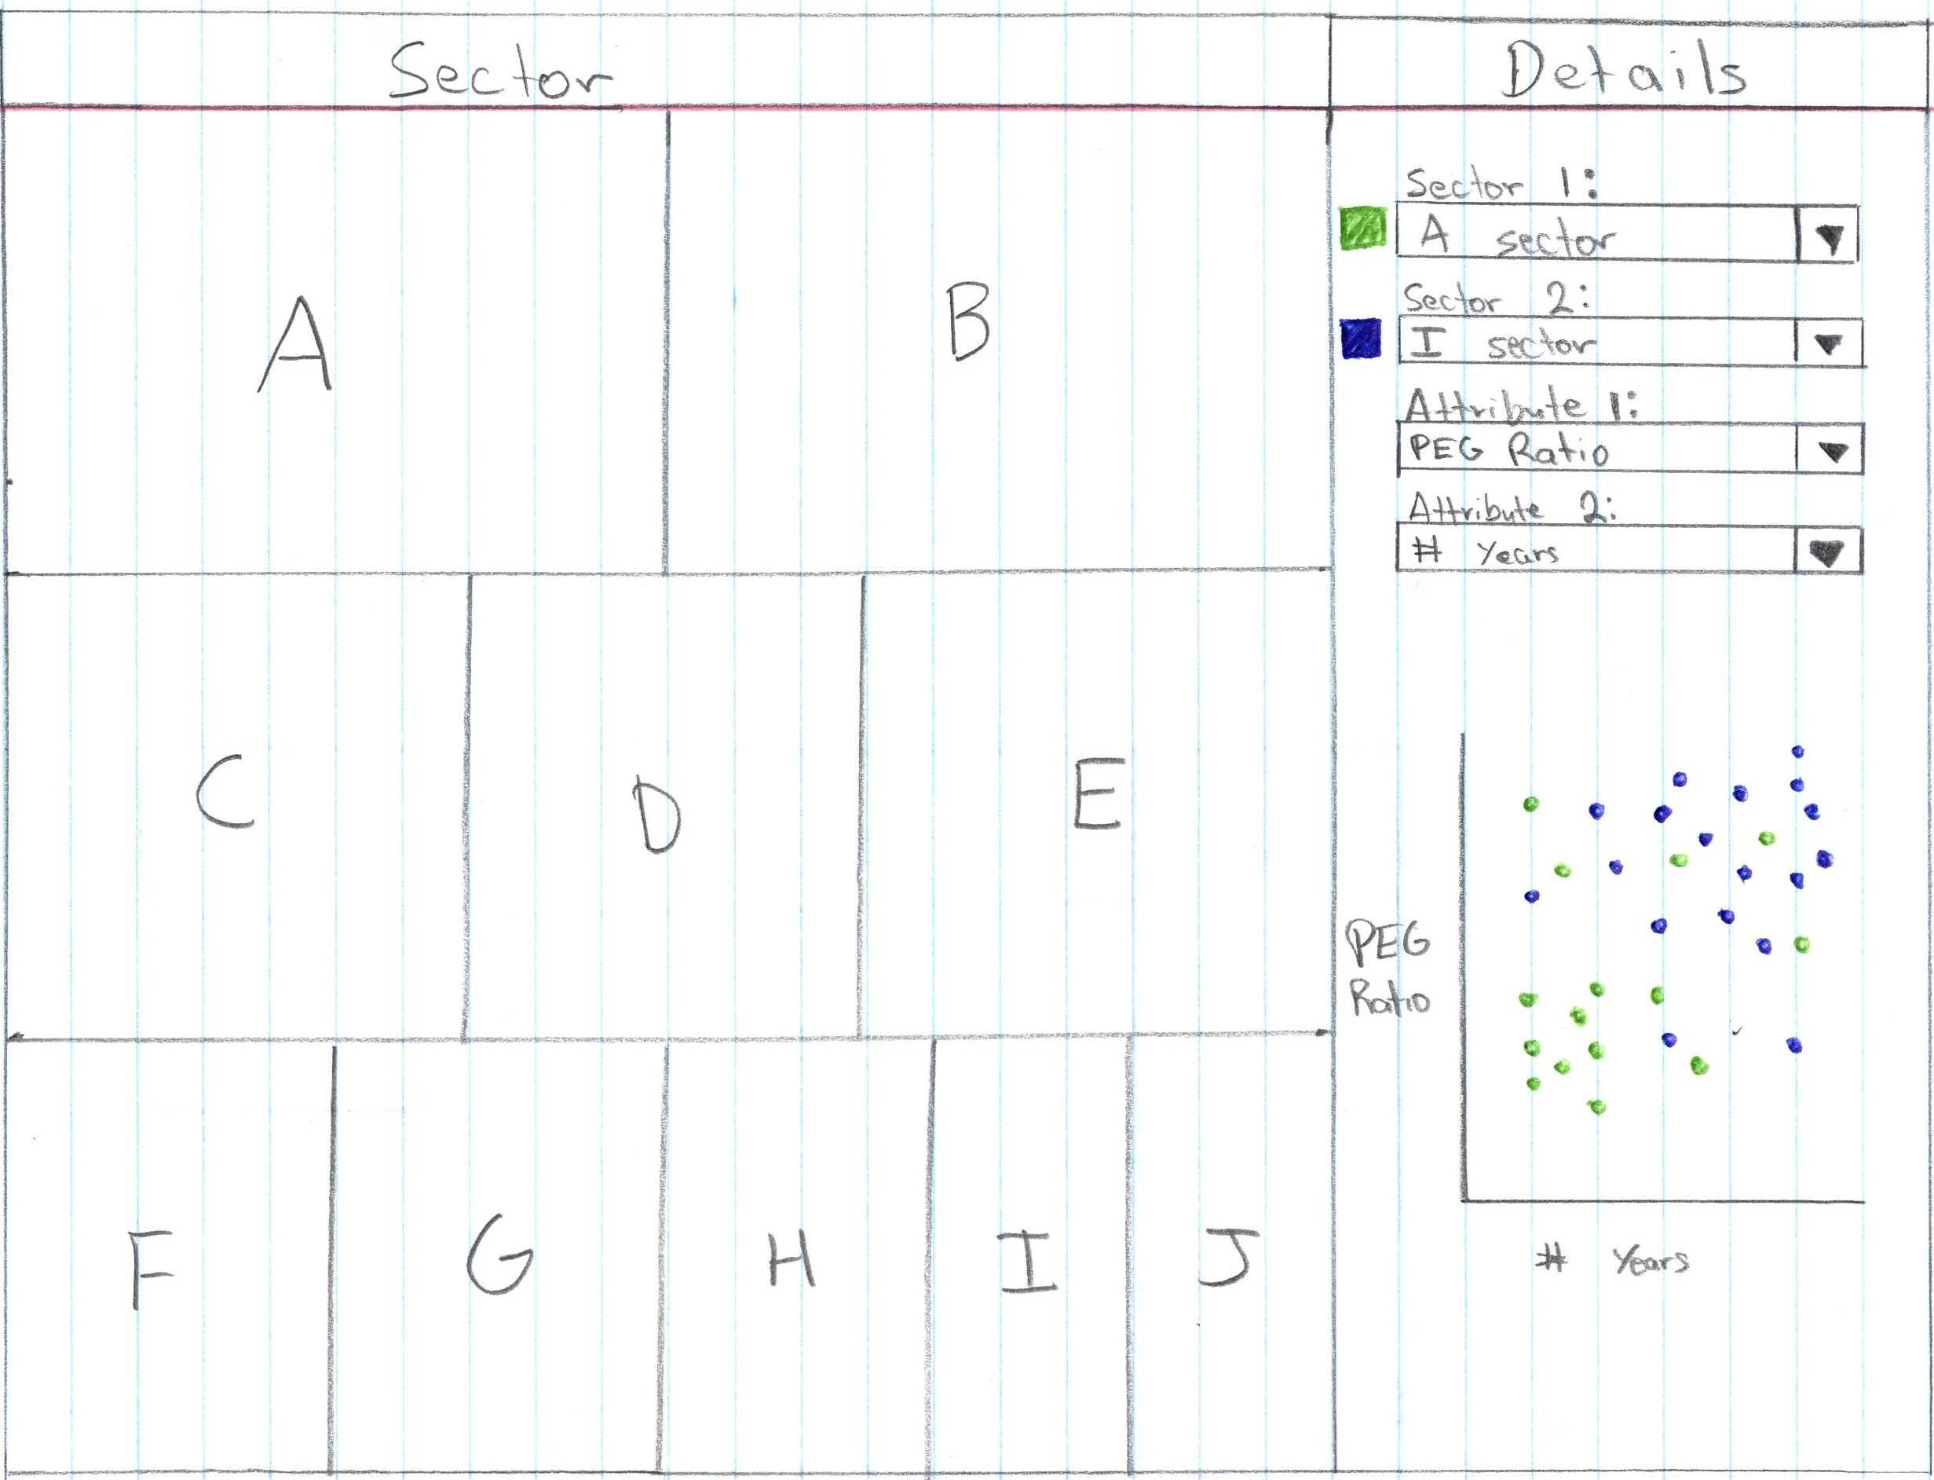

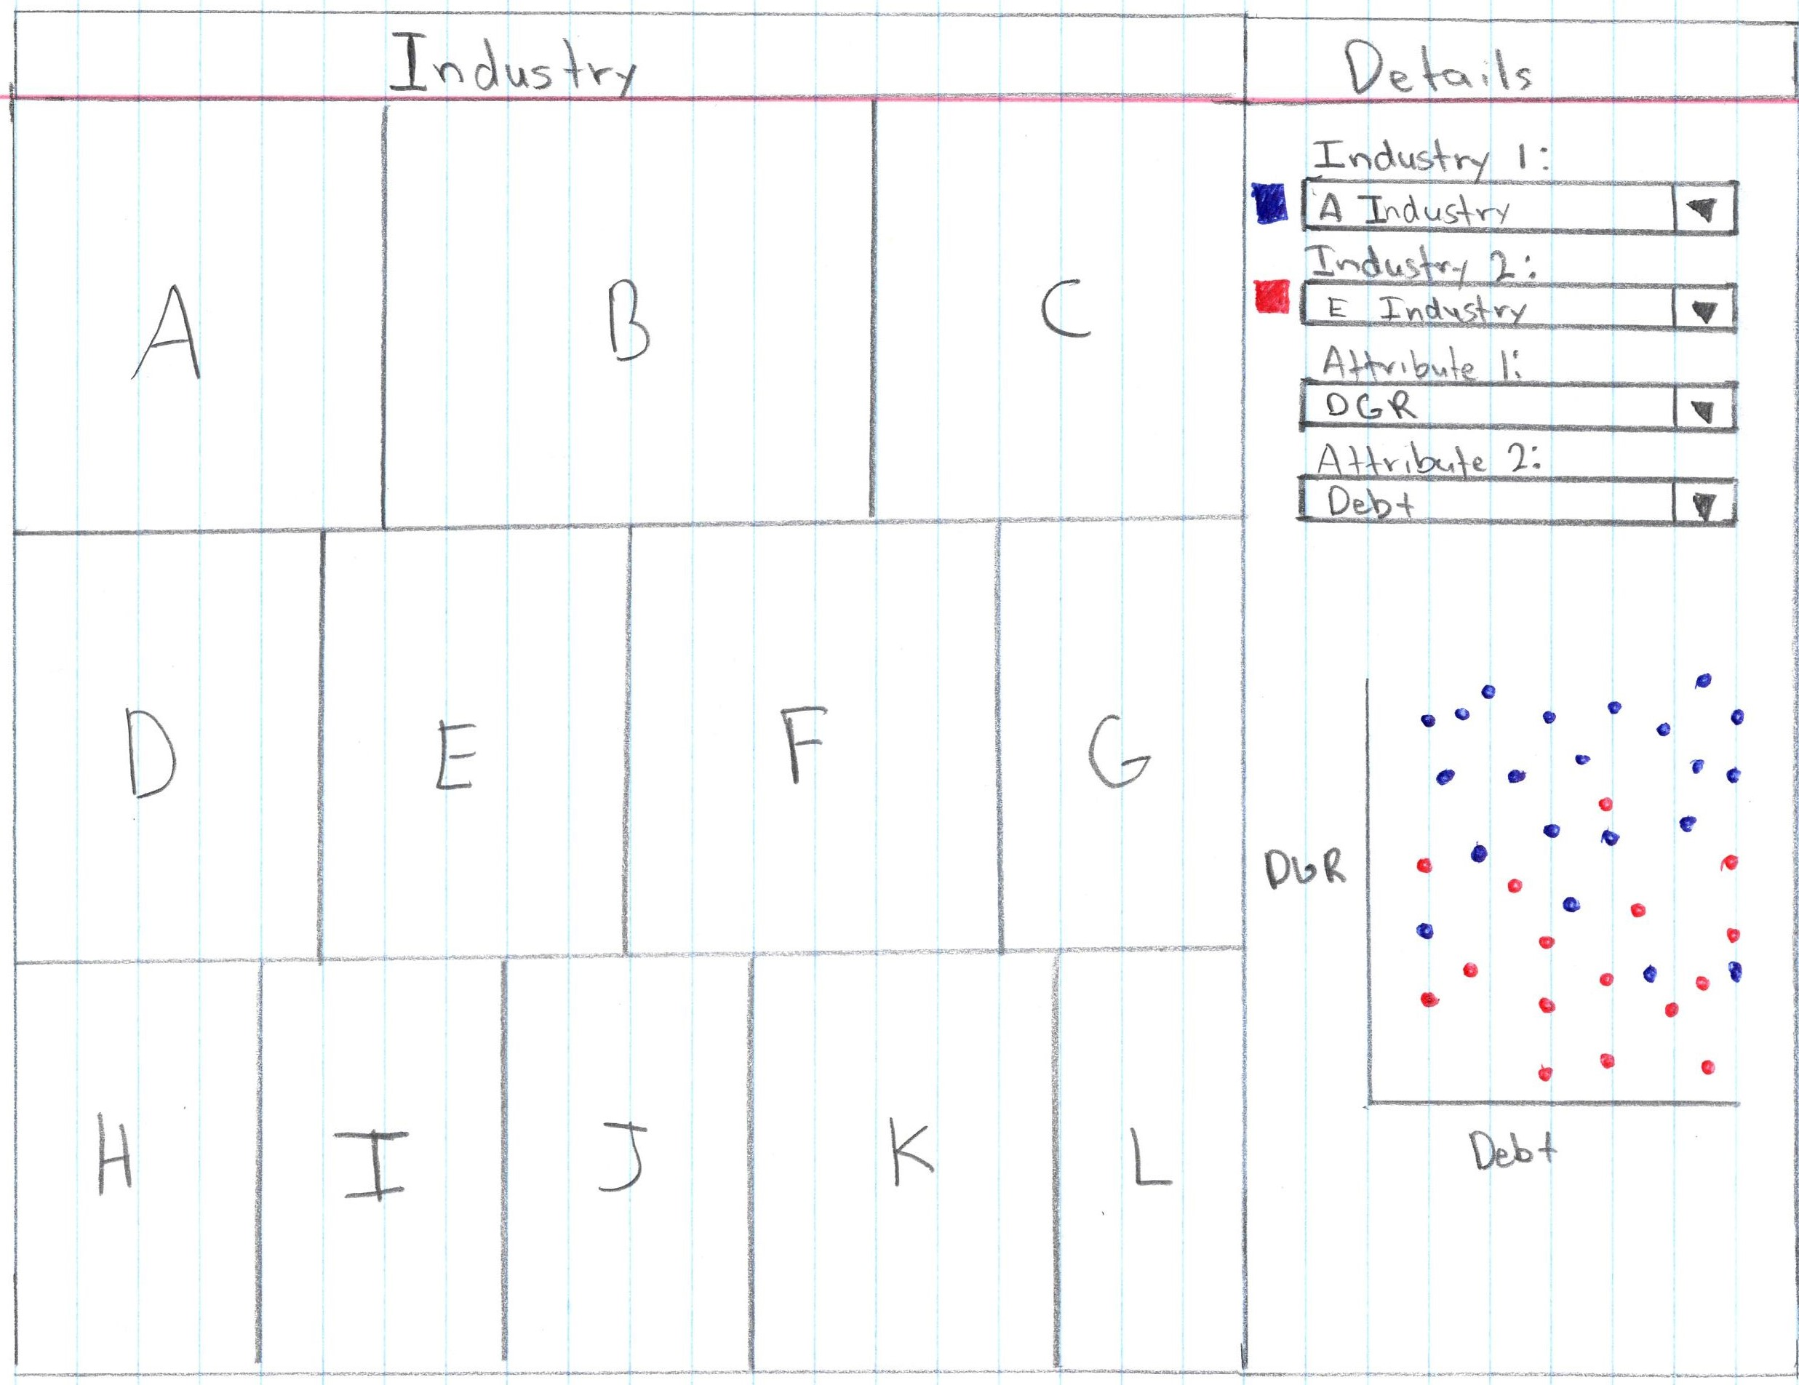

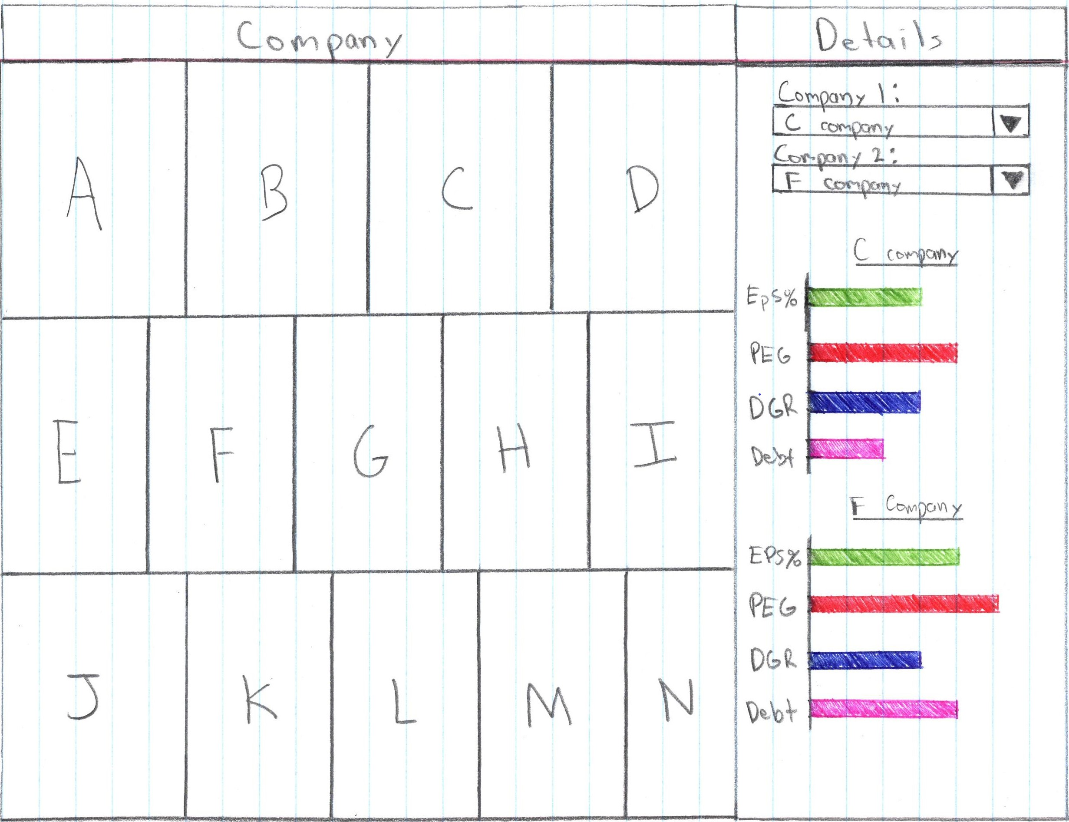

**Design Justifications**

**What data is shown**

The data being shown in the views are the statistics that will inform novice user on the best dividends. The quantitative data is categorized into the 3 distinct categories sector, industry, and company. The US Dividends dataset is a flat table dataset type, which will be visualized by our application for the users experience in learning the new information.

One issue with stock market data for novice users is that they probably have little or no knowledge of the data semantics. The attributes that will be available in this application are:

* **EPS % payout** - Calculates the annual dividend as a percentage of trailing twelve months Earnings Per Share.
* **TTM EPS** - Shows earnings per share for the most recently reported trailing twelve months.
* **PEG Ratio** - Shows the price/earnings ratio divided by 5-year estimates growth rate.
* **TTM ROE** - Shows the trailing twelve months' rate of return on shareholder equity.
* **TY% Growth** - Shows the percentage change of this year's earnings estimate compared with last year's EPS.
* **NY% Growth** - Shows the percentage change of next year's earnings estimate compared with this year's estimate.
* **DGR** - (or Dividend Growth Rate) is the compound annual growth rate of the dividend for the periods shown.
* **No. Yrs** - Represents the number of consecutive years of higher dividends.
* **Debt/Equity**
* **Estimated dividends** to be paid in 2019

The dataset will be in a static file, but it could support dynamic streams, an issue with dynamic streams is if the dataset grows too much over time and becomes slow and if new attributes are added to the dataset there wouldn’t be a way to add them to the application. The attribute types are categorical, ordinal, and quantitative. The data will mainly be represented sequentially.

**Why is the task being performed**

The task is being performed to find the sectors, industries, and companies that pay out the best dividends and that have the highest potential for future possible investments.

The marks were chosen because they are effective in distinct points from the dataset. The points can be easily placed on a graph and show the correlation between any of the attributes that were chosen by the user. The bar chart is a simple way of showing the exact value of an attribute since length is very effective channel to portray data. The size of the rectangles and the colors for both the scatterplot and the bar chart provide and effective channel to show the separability.

The target audience for this application is people who are new to stock market data and who are looking for a place to invest their money or just gain an understanding of the stock market. This design was chosen because it’s easy for novice users to comprehend and navigate through the application without being overwhelmed. The users have a very limited amount of choices they can make. This has the benefit of making the application easier to use, but as a down side the application will not be as powerful as it could be otherwise.

The users main use of this application is to consume information with the main focus on enjoying the data, but it can also be used for discovering information and presenting information. This application does not support producing data.

The application supports for search include: lookup, locate, browse, and explore. The application also supports identify, compare, and summarise by the users decisions. The user can look at targeted information, examine trends, identify outliers, and find correlations in the data.

**How is the visual idiom constructed**

The visualization idiom is constructed by allowing the user to filter by sector then industry then company. This allows the user to select specific sections in the economy that are of interest to them.

The visual uses a variety of marks such as points, bars, and area to display the dataset. A few channels being used are size, for the size of each rectangle (EG. A bigger industry rectangle in the means more companies belong to that industry) and color (EG. color in the scatterplot represent individual companies).

Information about this project was gathered through our own questions as novices in this area. Questions such as “what is the most profitable sectors/industry to invest in?” and “how consistent do specific sectors/industries pay dividends in?”

The visual encoding and interaction was chosen based on our questions that we had. A problem driven approach was taken for this application. The user can select specific sectors, industries, and companies and compare within those selections the performance of those groups.

**Rule of Thumb**

**Eye Beat Memory** – using our eyes to switch between different views that are visible simultaneously has lower cognitive load than consulting our memory to compare a current view with what was seen before. The tree map is side-by-side with the scatter plot/bar chart that allows the user to easily switch between different locations of interest. There are only two areas of interest for the user: the tree-map on the left and the chart on the right.

**Memory and Attention** – Conscious search for items is an operation that grows more difficult with the number of items there are to be checked. The user is limited in the amount of attributes they can select for comparison to prevent them from becoming over whelmed. We plan to have two or three selections. There are three levels in total for the user to zoom in and zoom out and those levels are sector, industry, and company.

**Overview First, Zoom and Filter with Details on Demand** –The user can zoom in by sector, industry, and company. Also, the user can filter based on the attributes they wish to compare.

**Responsiveness is Required** – how much time it takes for the system to respond to the user actions.

**Getting it Right in Black and White –** Our low-fidelity prototypes make a good example of what it looks like in black and white. It shows that our application is not dependent on color to inform the user.

**Function First, Form Next** – focus is on function of the application first, then beauty next. Our goal was to create an application for novice users to answer specific questions about stock market dividends. Making it look beautiful was the last task we focused on.